Parental Leave at FSU

<https://hr.fsu.edu/?page=eoc/eoc_fmla>

All **employees** are eligible to take a maximum of six months of unpaid Parental Leave for the birth or adoption of a child. Parental Leave can be taken intermittently, but must conclude within six months of the birth or adoption of the child. Parental Leave runs concurrently with FMLA. For detailed information on Parental Leave, please see the Parental Leave Policy online.

**Graduate students** are considered OPS students and do not qualify for FMLA. They also do not accrue sick or vacation time. If a graduate student would like to take parental leave, they can take a leave of absence from graduate school (this is unpaid) and they will need to continue to pay for health insurance.

**Postdocs** are considered OPS employees and they qualify for FMLA. They do not accrue sick or vacation time. They are able to take unpaid leave via the FMLA.

Resources for pregnant students and postdocs: <https://thepregnantscholar.org/>

Student and Faculty handouts for FAQ on Title IX, pregnancy, and student rights: <https://thepregnantscholar.org/helpful-handouts/>

Childcare

Resources at FSU: <https://childcare.fsu.edu/parents>

Priority is given to full–time, currently enrolled FSU students and currently employed FSU faculty and staff, followed by FSU Alumni and finally other interested parents in the community.

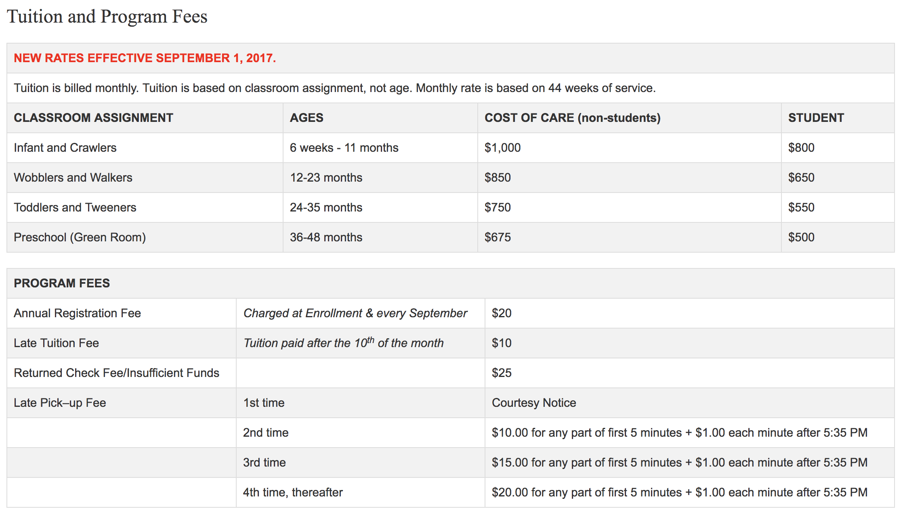

There is a current initiative looking to expand childcare available to FSU students, faculty, and staff. If interested in joining this effort, please contact Amy McKenna at mckenna@magnet.fsu.edu.

Healthcare Coverage for Dependents

<https://studentinsurance.fsu.edu/dependent-coverage>

United Healtchare Student Resources (UHCSR) is offering a 2019-2020 health insurance plan for dependents of FSU students. The dependent plan is only available to those students who have also purchased the student insurance plan. The dependent plan benefits mirror those of the student plan. For coverage details, go to <https://uhcsr.com/fsu> and view the plan brochure.